1. What is software? What is software engineering?

Software engineering has two parts: software and engineering. Software is a collection of codes, documents, and triggers that does a specific job and fills a specific requirement. Engineering is the development of products using best practices, principles, and methods.

What software engineering:

The application of a systematic, disciplined, quantifiable approach to the development, operation, and maintenance of software; that is, the application of engineering to software.

2 Explain types of software..

1Application software

2 system software

3 Driver software.

4 Middle software

5 Programming software

**1 *Application software*.**The most common type of software, application software is a computer software package that performs a specific function for a user, or in some cases, for another application. An application can be self-contained, or it can be a group of programs that run the application for the user....

**2 System software.** These software programs are designed to run a computer's application programs and hardware. System software coordinates the activities and functions of the hardware and software....

**3 Driver software.**Also known as device drivers, this software is often considered a type of system software. Device drivers control the devices and peripherals connected to a computer, enabling them to perform their specific tasks. Every device that is connected to a computer needs at least one device driver to function.

4 Middleware.The term *middleware* describes software that mediates between application and system software or between two different kinds of application software.

**5 Programming software.** Computer programmers use programming software to write code. Programming software and programming tools enable developers to develop, write, test and  other software programs.

4 what is SDLC? Explain each phase of SDLC

The software development lifecycle (SDLC) is the cost-effective and time-efficient process that development teams use to design and build high-quality software. The goal of SDLC is to minimize project risks through forward planning so that software meets customer expectations during production and beyond.

3 Explain each phase of SDLC

1 Requirements

2 Design

3 Implementation and code

4 Testing

5 Deployment

6 Maintenance

1Requirements

This phase involves gathering information about the software requirements from stakeholders, such as customers, end-users, and business analysts.

2 Design

In this phase, the software design is created, which includes the overall architecture of the software, data structures, and interfaces.

3 Implementation and code

The design is then implemented in code, usually in several iterations, and this phase is also called as Development.

4 Testing

The software is thoroughly tested to ensure that it meets the requirements and works correctly.

5 Deployment

After successful testing, The software is deployed to a production environment and made available to end-users

6 Maintenance

This phase includes ongoing support, bug fixes, and updates to the software.

4 What is DFD? Create a DFD diagram on Flipkart

FD is the abbreviation for Data Flow Diagram. The flow of data of a system or a process is represented by DFD. It also gives insight into the inputs and outputs of each entity and the process itself. DFD does not have control flow and no loops or decision rules are present. Specific operations depending on the type of data can be explained by a flowchart. It is a graphical tool, useful for communicating with users ,managers and other personnel.

Create a DFD diagram on Flipkart

1 Dfd

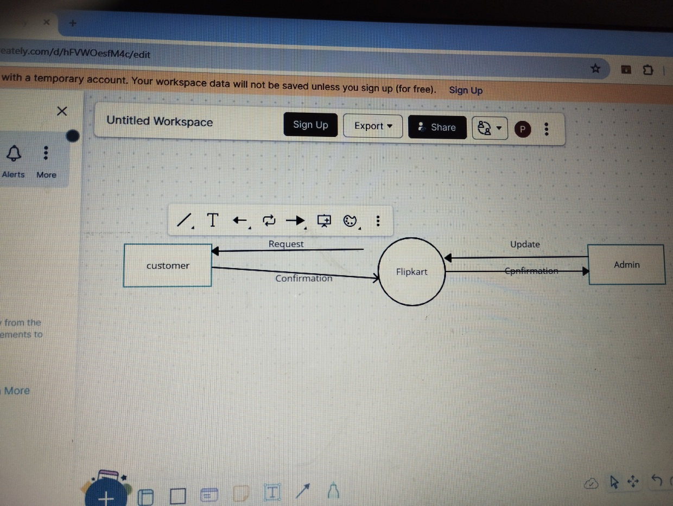

2 level dfd 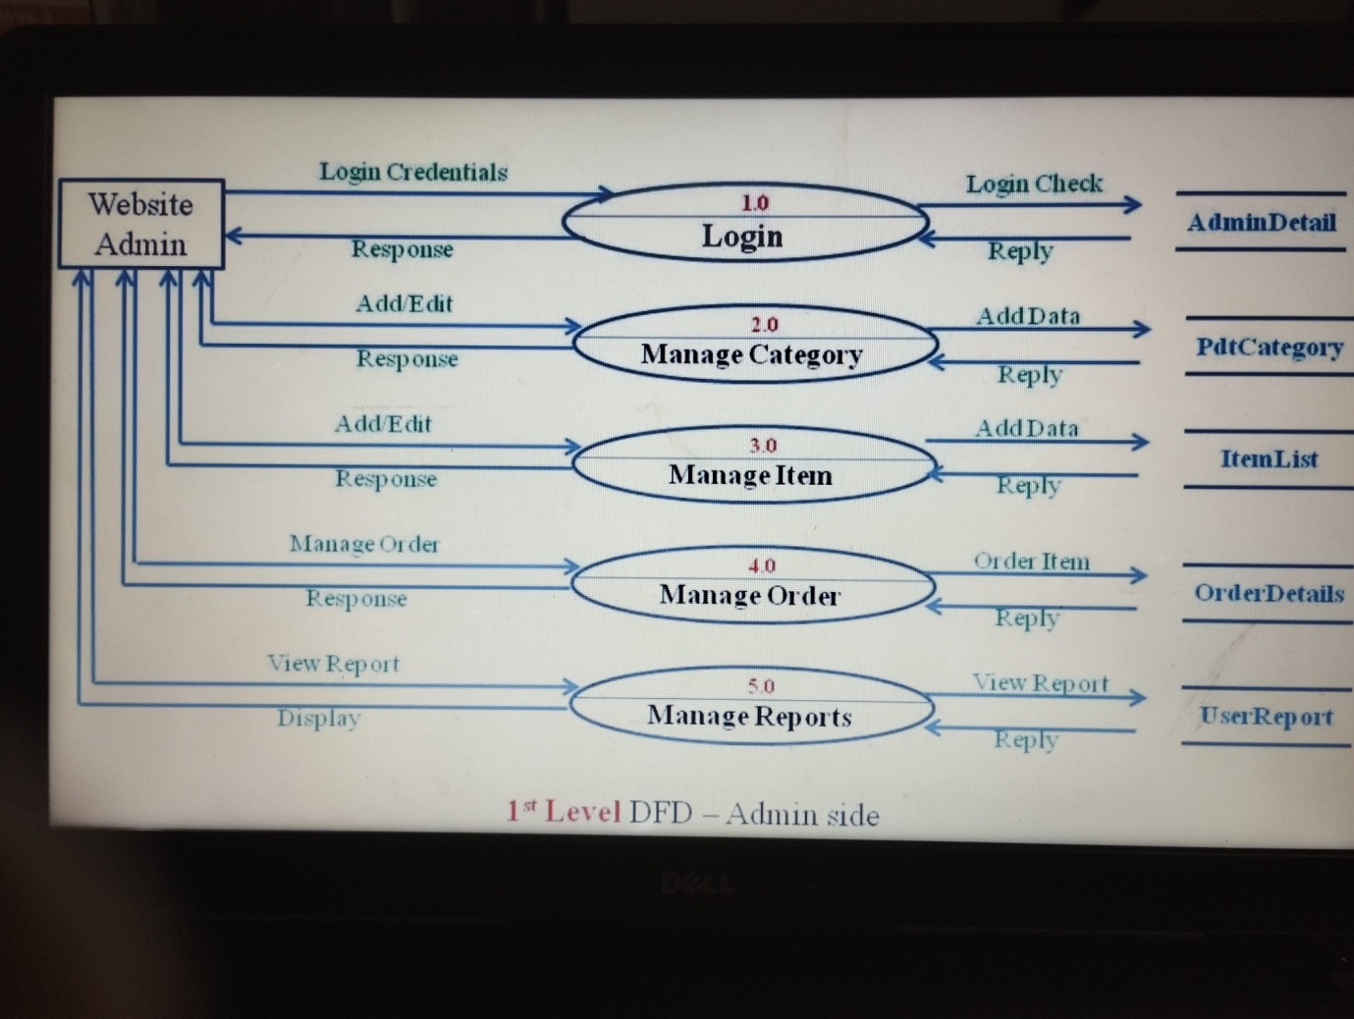

5 What is Flow chart? Create a flowchart to make addition of two number.

 process flowchart, process flow diagram

Variations: macro flowchart, top-down flowchart, detailed flowchart (also called process map, micro map, service map, or symbolic flowchart), deployment flowchart (also called down-across or cross-functional flowchart), several-leveled flowchart.

Create a flowchart to make addition of two number.

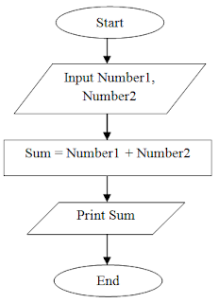

6. What is Use case Diagram? Create a use-case on bill payment on paytm.

 use case diagram is a way to summarize details of a system and the users within that system. It is generally shown as a graphic depiction of interactions ..

Create a use-case on bill payment on paytm.

